4.6 I can assess when there is a problem with collaborative technologies and when to get expert help.

Software problems.

**1. Free up RAM by closing other open programs.**

Every piece of software uses Random Access Memory (RAM). The more software that's running on your computer, the more RAM it uses. This can be especially problematic if you're using older machines that don't have a lot of RAM. So if a software program refuses to load or is running slowly, the first thing to do is to close all other open applications.

If you want to find out which open applications might be hogging your RAM, both Windows and Macintosh operating systems (OS) have tools that display this information:

* **In Windows**, hit Ctrl+Alt+Delete, then choose the Start Task Manager option. From the window that appears, click the Processes tab, then click the Memory menu item. This sorts all open processes based on the amount of RAM they're using. You can shut down a runaway process by clicking the End Process button. Before you do that, you may want to do a bit of research on the process to ensure that you don't accidentally stop a critical process or program.
* **In Mac OS X,** use the Activity Monitor (called the Process Viewer in older versions of OS X). Access the Activity Monitor by going to Applications > Utilities. Once you've called up the Activity Monitor, sort programs based on RAM usage by clicking the column labelled "Real Memory."

**2. Restart the software.**

Software problems can stem from a conflict with other programs or simply from difficulties the software encountered when starting up. Shutting the program down and restarting it can sometimes resolve these issues.

**3. Shut down and restart your computer.**

If restarting the problematic program doesn't resolve the issue, try rebooting your computer. Once the computer has fully restarted, re-launch the application in question and see if the problem has been resolved.

**4. Use the Internet to find help.**

No matter what software problems you encounter, chances are it's happened to someone else. So there's a good chance you can find help on the Internet. Here are a few places to get started:

* **Search for answers:** In your search engine query, include the software program name and version, the problem you encountered, and the circumstances under which the problem occurred. If you received a specific error message, enter the exact error message text, along with the name of the application.
* **Check the vendor's website:** Most software vendors provide some form of product help, such as answers to frequently asked questions, product documentation, or user discussion forums.
* **Check other websites:** TechSoup's article [Learning About Technology Online](https://www.techsoup.org/support/articles-and-how-tos/learning-about-technology-online) lists a number of other websites that offer technology tutorials, articles, and discussion forums.

**5. Undo any recent hardware or software changes.**

Changes to software and hardware can sometimes cause software problems, such as:

* **Conflicts with other software:** Newly installed software may conflict with other software. For example, Symantec Norton Antivirus can conflict with competing antivirus products. So, if you recently installed another antivirus program and Norton Antivirus no longer works correctly, uninstalling the other antivirus product could solve your problem.
* **Changes to computer settings:** Undo any recent changes to your computer's settings and try launching the software again. For example, the Windows Control Panel includes an option to "Set Program Access and Defaults," which allows you to disable access to certain applications. If you accidentally disable access to a program here, the program may not run.
* **Conflicts with new or improperly configured hardware,** such as scanners and printers. If you've recently connected new hardware to one of your computers, try disconnecting the hardware and see if that corrects the software issue.

**6. Uninstall the software, then reinstall it.**

Sometimes, software problems occur because critical application files have been removed, updated, or deleted. For example, many Windows applications use Dynamic Link Library (DLL) files to perform basic tasks. Often, several applications will use the same DLL file. If you've recently removed one program from your computer, it's possible you removed DLL files that another program relied on. Similarly, adding a program could add or update DLL files. Applications that were dependent on those DLL files may become unstable or stop working entirely.

To ensure that all the necessary files are intact, you can completely uninstall the problematic software, then reinstall it. Even if you remove a program using its built-in uninstall wizard (if it includes one), it's still a good idea to check your hard drive's Program Files folder — usually located on the C drive — for any remnants of the program and delete any files or folders you find.

Before reinstalling, check to see if there's a new version of the program available. The vendor or developer might have introduced bug fixes that address the issue you're having.

**7. Look for software patches.**

Software vendors may also fix bugs by issuing patches — small software updates that address known problems. Even if you're using the most current version of the software, there may be a more recent patch available for that version.

**8. Scan for viruses and malware.**

Viruses, spyware, and other forms of malicious software (or "malware") can cause software to freeze, crash, or quit working entirely.

If tips 1 through 8 haven't helped solve your software problem, you may also want to scan the computer using both antivirus and anti-malware tools to find and remove viruses and malware. Use the most thorough scan mode available, and remember to restart your machine if the antivirus or anti-malware programs found any threats.

**9. Check for a firewall conflict.**

Some organizations may choose to install personal firewall software on each computer, rather than a centralized hardware or software-based firewall. Personal firewalls can be an important line of defense against hackers and other security threats, but they can also cause software conflicts.

Firewalls frequently display messages asking whether it should allow a program to run or block it. Therefore, it's possible to accidentally tell the personal firewall to block a program from running. Check the firewall's settings to see if the problematic software was added to the firewall's list of programs to block. If so, change the firewall's settings to allow the software to run, then check to see if you're still having issues with your software.

**10. Boot up in Safe Mode.**

Some software malfunctions can be caused by OS settings or other system problems. Windows and Mac operating systems both offer a troubleshooting environment known as Safe Mode. Safe Mode disables non-critical applications and processes, which theoretically makes it easier to isolate problems.

Most Windows computers allow you to enter Safe Mode by pressing the F8 key as your computer is booting up. On a Mac, enter Safe Mode by pressing the Shift key while your computer boots up (or immediately after it boots up).

Once your computer is in Safe Mode, launch the problematic software and try to replicate the problem you had while your computer was in normal mode. If you don't have the same problem in safe mode, there's a good chance that the issue was caused by your OS or another program, not by the application you are troubleshooting.

**11. Defragment your hard drive.**

As a final troubleshooting step, you might defragment your computer's hard drive. Defragmenting rearranges your hard drive's file structure so that the system runs more efficiently. Defragmenting will probably be most useful if you're experiencing overall sluggishness on your computer because defragmenting is meant to make your entire system run faster. Note that defragmenting a hard drive applies primarily to Windows-based computers.

Most recent Windows editions — including XP, Vista, and Windows 7 — include a built-in disk-defragmentation tool. To launch it, go to Start > All Programs > Accessories > System Tools > Disk Defragmenter. Be aware that defragmenting a hard drive can be time-consuming, so make sure to perform this task when you will be away from your computer for a few hours.

Information source from TechSoup

**HOW TO UPDATE DRIVERS ON WINDOWS**

The most simple way to do that is to [update your OS](https://www.guidingtech.com/update-windows-10-offline/). It will not only install new features, bug fixes, and security patches but also update drivers. Press Windows key+I to Settings and select Update & Security option.

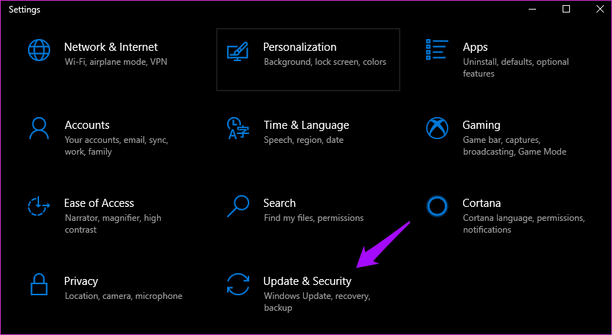

You can check for new updates here and apply them once they are downloaded and ready.

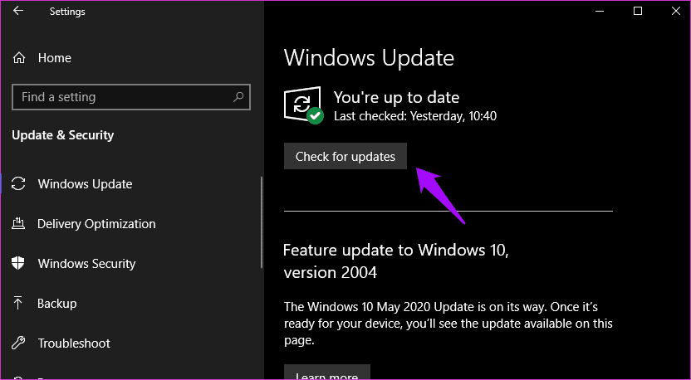

Here’s another way that gives you more control. The Device Manager is where you can view all the hardware devices installed on your computer. Search for and open it from the Start menu. You can also press the Windows+X keyboard shortcut to find it.

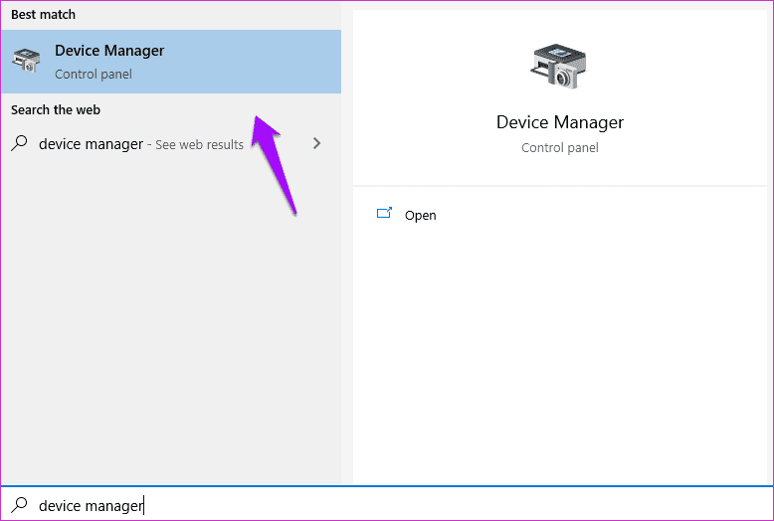

Double-click an option to expand it. Do you want to update mouse drivers? Expand Mice and other pointing devices, select your trackpad provider or HID option for external USB-connected mouse, right-click, and select Update driver option.

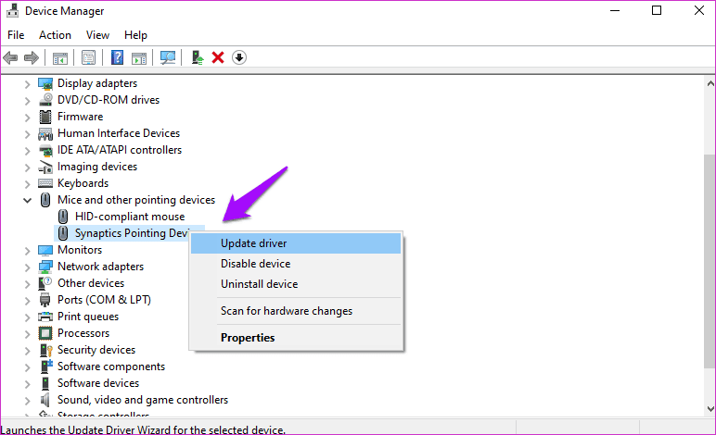

The last option is to visit the device manufacturer’s website and download and install the drivers yourself. You will follow the same steps as above but select ‘Browser my computer for driver software’ instead and select the driver file in Device Manager.

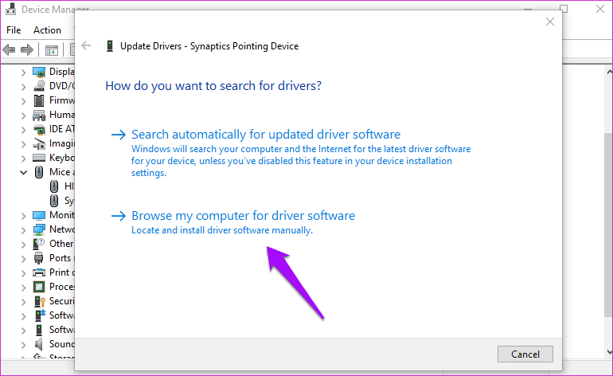

**HOW TO CHECK DRIVER VERSION AND UPDATE DATE**

Go back to the Device Manager and right-click on the device you want to check. Select Properties this time and click on the Drivers tab.

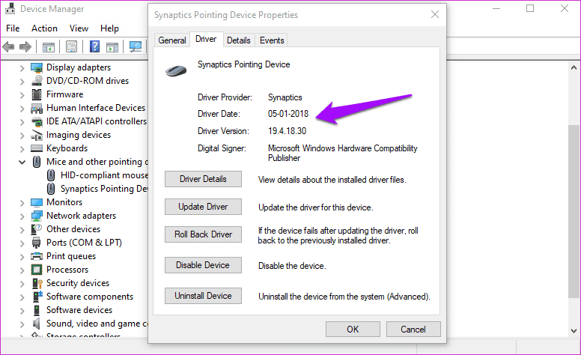

You will see the device driver version along with the date it was installed on.

**UNINSTALL OR ROLLBACK DRIVER**

Some troubleshooting steps involve uninstalling the driver or [rollback](https://www.guidingtech.com/how-to-roll-back-drivers-in-windows-7). The latter simply means going back to a previous version of the driver.

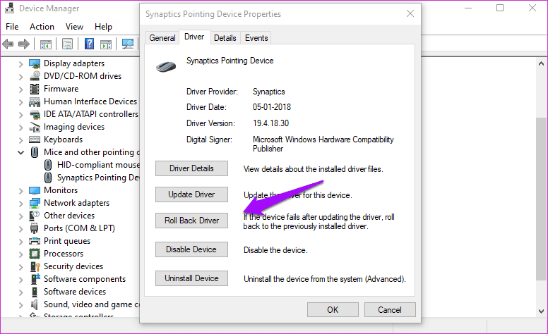

Both the options are available under the Driver tab in Properties menu. You can also uninstall the device itself here and then reinstall as we saw above.

**DRIVE SAFE**

Drivers play an important part in pretty much whatever you do on your computer. An outdated or missing driver will render the device simply useless. As much as you dread updates, installing the latest version will ensure smooth functioning of the hardware with the OS. That is why we suggest users update them on Windows 10 computers because it solves the error more often.

**System requirements for installing Windows 10**

These are the basic requirements for installing Windows 10 on a PC. If your device does not meet these requirements, you may not have the great experience intended with Windows 10 and might want to consider purchasing [**a new PC**](https://www.microsoft.com/en-us/windows/devices).

|  |  |
| --- | --- |
| **Processor:** | **1 gigahertz (GHz)** or faster [**compatible processor**](http://aka.ms/CPUlist) or System on a Chip **(SoC)** |
| **RAM:** | 1 gigabyte (GB) for 32-bit or 2 GB for 64-bit |
| **Hard drive size:** | 32GB or larger hard disk  Note: See below under “More information on hard drive space to install or update Windows 10” for more details. |
| **Graphics card:** | Compatible with DirectX 9 or later with WDDM 1.0 driver |
| **Display:** | 800x600 |
| **Internet Connection:** | Internet connectivity is necessary to perform updates and to download and take advantage of some features. Windows 10 Pro in S mode, Windows 10 Pro Education in S mode, Windows 10 Education in S mode, and Windows 10 Enterprise in S mode require an internet connection during the initial device setup (Out of Box Experience or OOBE), as well as either a Microsoft account (MSA) or Azure Activity Directory (AAD) account. Switching a device out of Windows 10 in S mode also requires internet connectivity. |

[**How to Check if Your Windows 10 PC Can Run Windows 11**](https://www.howtogeek.com/737021/how-to-check-if-your-windows-10-pc-can-run-windows-11/)

[**JOE FEDEWA**](https://www.howtogeek.com/author/joefedewa/)

[@tallshmo](https://twitter.com/tallshmo) AND [**CHRIS HOFFMAN**](https://www.howtogeek.com/author/chrishoffman/)

UPDATED OCT 1, 2021, 3:08 PM EDT | 1 MIN READ

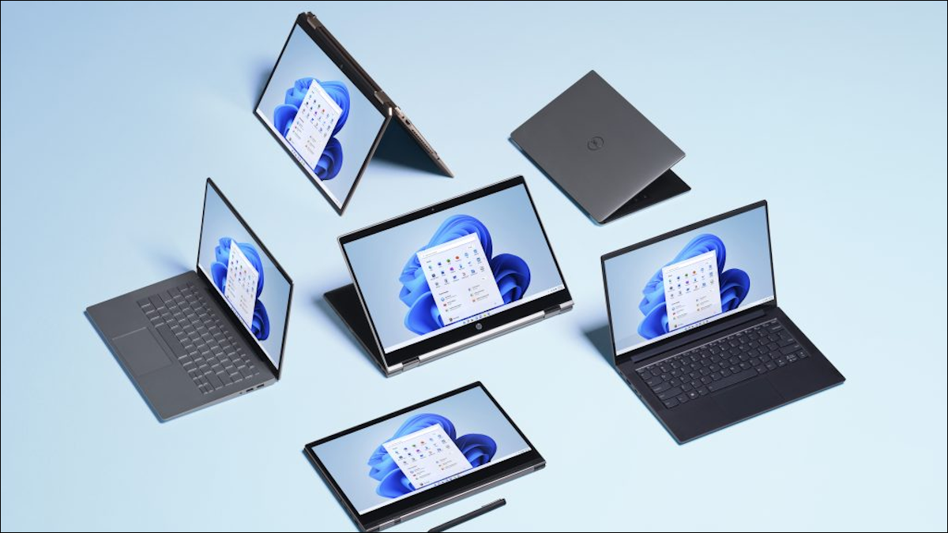Microsoft

[Windows 11](https://www.howtogeek.com/737031/windows-11-whats-new-in-microsofts-new-os/) will be released on October 5, 2021. The latest version of Windows has pretty strict system requirements and [only officially supports PCs with modern CPUs](https://www.howtogeek.com/739029/why-doesnt-windows-11-support-my-cpu/). Microsoft has a handy tool to help you check, but [even unsupported PCs will be allowed to upgrade](https://www.howtogeek.com/751960/microsoft-backs-down-windows-11-will-run-on-any-pc/).

Microsoft released a “PC Health Check” app that, among other things, can tell you if your PC meets the [system requirements to run Windows 11](https://www.howtogeek.com/737029/what-are-the-minimum-system-requirements-to-run-windows-11/). Those system requirements can also be [found on Microsoft’s website](https://www.microsoft.com/en-us/windows/windows-11-specifications) if you’re interested.

To check if your Windows PC can run Windows 11, download the “[PC Health Check](https://aka.ms/GetPCHealthCheckApp)” app. (Clicking that hyperlink will start the download immediately, and you can also find it [linked to on Microsoft’s website](https://click.linksynergy.com/deeplink?id=2QzUaswX1as&mid=24542&u1=htg/737021&murl=https%3A%2F%2Fwww.microsoft.com%2Fen-us%2Fwindows%2Fwindows-11%23pchealthcheck).)

Next, open the downloaded file and accept the terms to install it.

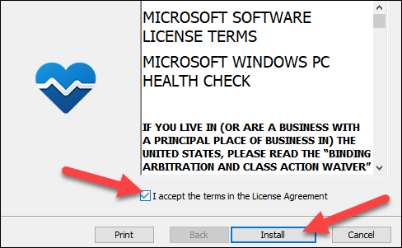

Then check the “Open Windows PC Health Check” box and select “Finish.”

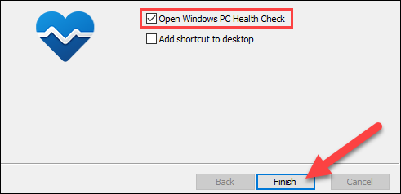

ADVERTISEMENT

You’ll see a Windows 11 section at the top of the app. Select the blue “Check Now” button.

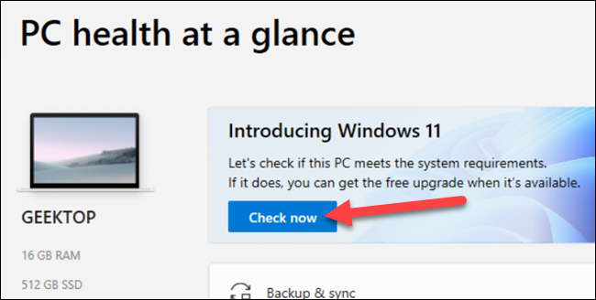

If your PC is compatible, a window will open saying that “This PC meets Windows 11 requirements.”

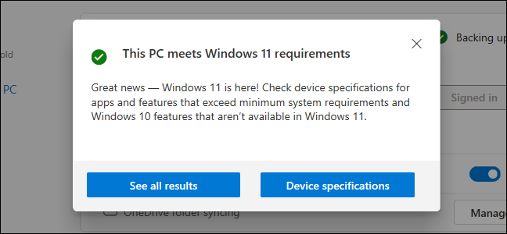

If your PC isn’t officially supported, a window will open saying that your PC doesn’t currently meet Windows 11 system requirements.

The tool will also tell you why and provide you with links to more information. For example, if it says the problem is only that [TPM 2.0](https://www.howtogeek.com/738163/why-does-windows-11-need-tpm-2.0/) is not enabled, you may be able to [enable TPM from within your computer’s UEFI firmware](https://www.howtogeek.com/737171/how-to-fix-this-pc-cant-run-windows-11/), which is the modern alternative to the BIOS. If [Secure Boot](https://www.howtogeek.com/116569/htg-explains-how-windows-8s-secure-boot-feature-works-what-it-means-for-linux/) isn’t currently enabled, you may be able to enable it.

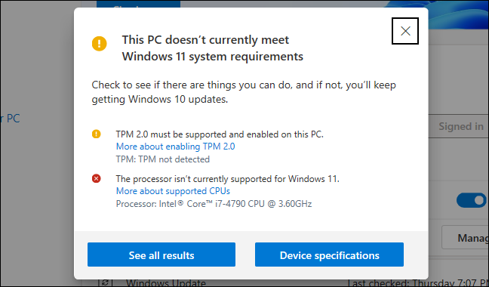

There is also a helpful “Device specifications” button that links to a [web page with more information](https://click.linksynergy.com/deeplink?id=2QzUaswX1as&mid=24542&u1=htg/737021&murl=https%3A%2F%2Fwww.microsoft.com%2Fen-us%2Fwindows%2Fwindows-11%3FOCID%3D2_pchc_windows_app_omc_win) about the system requirements. That’s all there is to it!

If your PC isn’t officially compatible, you will be able to [upgrade to Windows 11 anyway](https://www.howtogeek.com/759925/how-to-install-windows-11-on-an-unsupported-pc/), but you may run into bugs and Microsoft says there’s no guarantee your PC will continue to receive security updates.

Hardware Problems

How to Troubleshoot Common PC Hardware Problems:

Some of the most common PC hardware problems that need troubleshooting are:

1. Your computer won’t turn on.
2. Your computer turns on, but still doesn’t work.
3. Your computer screen freezes.
4. Your computer has insufficient memory.
5. You get a CMOS error.
6. Your operating system is missing or your hard drive isn’t detected.
7. You get the blue screen of death.

When it comes to hardware, some techs may have trouble assessing what steps to take to figure out what’s wrong and how to repair it. Which component is having the issue? Should you just replace the component? Should you try to troubleshoot the software first?

In this article we’ll go over how to troubleshoot common PC hardware issues (seven of them, to be exact) and the best way to go about fixing them. Remember this, though. The most basic tip is to always try the most obvious solutions first. It could save you a lot of time and frustration.

Problem #1: Your Computer Won’t Turn On

This is a common problem that often offers a simple solution.

1. Is everything plugged in? I can’t tell you how many times I have come across a “broken” computer that simply had an unplugged component.
2. Try plugging into different power outlets. It isn’t uncommon to blow a fuse, especially with more power-hungry systems.
3. Is either the monitor, mouse, or keyboard the only thing not working? If so, try plugging in a different one to see if that does the job. Most of the time, replacing one of these is cheaper than attempting a repair.

Once you’ve completed the above steps, it’s time to look at the tower.

1. Are the lights on in the front or back of the tower? If not, the power supply unit (PSU) may be turned off.
2. Next, you can open up your tower and look at the motherboard. Most have a small LED light built in to show if power is running to the motherboard. If it’s turned off, you can either try using a PSU tester, or replace the PSU. Never try to open a PSU and try to repair it yourself as this is extremely dangerous.

Problem #2: Your Computer Turns On, But Still Doesn’t Work

If power is obviously flowing to the computer system and its peripherals, there may be a component issue. When you first turn on the computer, do you hear or see anything out of the ordinary? Many times the computer’s Power-On Self-Test (POST) will let you know what’s going on with the machine.

Beep Codes

If you hear any beeps when your computer turns on, they can help you troubleshoot common PC hardware problems. Here’s a list of beep codes (hint: remember these if you’re taking the [COMPTIA A+](https://www.pluralsight.com/paths/comptia-a-220-1001-and-220-1002) exam).

* No beep but the system turns on and runs fine - Under normal circumstances, most computer systems will beep one short beep when turned on. If yours doesn’t, your “beeper” may have died out.
* No beep - The power supply is not plugged in or turned on. Or, the power supply is completely dead.
* Steady, short beeps - The power supply may be bad or the voltages might be wrong. A replacement would usually be necessary.
* Steady, long beeps - The power supply has gone bad.
* Long, continuous beep - Your Random Access Memory (RAM) sticks may have gone bad. If there is more than one stick installed, try taking one out to see if the computer boots. If it does not, try the same thing with the other stick. This will tell you which stick has gone bad and you can replace or upgrade accordingly. If there is only one stick installed, you will need to replace or upgrade it to fix the problem.
* One long, two short beeps - There has been a video card failure. Your first action is to try reseating the video card. This often solves the problem when the computer system is connected to projectors because the VGA/DVI/Video cable gets moved so often that the card can be slowly unplugged. If reseating doesn’t work, replace the video card.

Problem #3: Your Computer Screen Freezes

[When your computer freezes](https://www.computerhope.com/issues/ch000700.htm) and isn’t responsive to your mouse or keyboard, the first thing to do is just wait. Sometimes it will just take a few minutes for your computer to process. Then, end-task the non-responding program. If that doesn’t work, turn off the computer by holding down the power button and then rebooting into Safe Mode (don’t forget about saving your work first, if you can).

If you’ve tried all of this and your computer still won’t unlock, you may be dealing with either defective hardware or a defective device driver. If this is your case, replace the defective piece immediately so it doesn’t cause further damage.

Another thing you could be dealing with is a virus that is overwhelming your system. Run a virus scan, [remove the virus](https://www.avg.com/en/signal/how-to-get-rid-of-a-virus-or-malware-on-your-computer), recover or reinstall damaged files or software, and implement the latest security software.

Problem #4: Your Computer Has Insufficient Memory

Receiving an “insufficient memory or disk space” error message can usually be solved (at least temporarily) by closing extra windows to free up some RAM. If you’ve done that and the error still comes up, you can try rebooting your computer and installing the latest operating system update.

If you really don’t have enough available memory and space (which can be checked in Windows 10 by pressing the Windows-R button and typing *perfmon*in the *Open*field to run the Performance Monitor), you can uninstall or delete any unused or unnecessary files, especially those of the video/music type. Your final solution is to [add more RAM](https://www.crucial.com/articles/about-memory/how-to-upgrade-desktop-memory).

Problem #5: You Get a CMOS Error

The [CMOS](https://www.computerhope.com/jargon/c/cmos.htm) (complementary metal-oxide semiconductor) is an onboard chip that stores information ranging from the time and date to system hardware settings. If you get a CMOS alert message showing up on your screen, it’s likely you need to [replace the CMOS battery](https://www.computerhope.com/issues/ch000239.htm) located on the motherboard. Remove it carefully, insert a new battery that is exactly the same as the old one, and enter the CMOS values to the defaults.

Problem #6: Your Operating System Is Missing or Your Hard Drive Isn’t Detected

If the message “Missing Operating System” shows up on your screen, there are four possibilities the problem could be (and four ways to solve it):

1. The basic input/output system (BIOS) doesn’t detect Windows’ hard disk, or the disk failed. If you know how, take out the hard drive and reconnect it. If that doesn’t work, the hard drive’s interface is forbidden or the hard drive is seriously damaged.

Restart the computer and watch for the message telling you which key to strike to go into the BIOS. The key can vary from system to system so you may need to use a search engine to find the instructions for your system. Be sure to strike the specified key as soon as you see the message.

In the BIOS highlight the hard drive and set it to “Auto”. If it’s still invisible, you need a hard drive repair or replacement.

2. The BIOS settings are incorrect. Set the BIOS back to Default State.

3. The Master Boot Record (MBR) is damaged or corrupted. Rebuild the MBR using either the Windows installation disk, the Windows repair disk, or a bootable partitioning tool.

4. The Windows boot file partition isn’t active. Start the computer using a bootable partitioning tool. If that doesn’t work, set the wrong partition to ‘inactive’ and activate the correct partition.

Problem #7: The Blue Screen of Death

The blue screen of death (BSOD) appears when Microsoft Windows has an unrecoverable, critical error that causes a crash and subsequent data loss. This can be caused by the low-level software in Windows crashing.

When the BSOD occurs, the computer automatically creates a minidump file and restarts the computer. If the blue screen appears again, follow the prompts, identify and search for the error code online, and learn how to fix the problem.

Some of the common solutions are to:

* Make sure your computer isn’t overheating. If it is, close unused applications, check the fan is working properly, and conduct a good dusting after the computer is turned off before trying other [solutions for an overheating PC](https://www.hongkiat.com/blog/cool-down-heating-pc/).
* Boot into Safe Mode before trying to fix a problem.
* Test your hardware components and check the computer’s memory for errors.
* Check for incorrectly installed or buggy drivers. Install updated drivers.
* Scan for Malware that is causing the crash.
* Reset or reinstall Windows.

Use System Restore to get your computer back to its previous state. If it works, you probably have a software problem on your hands.

Signs You Need to Call a Professional

If you don’t feel confident doing any of these troubleshooting steps, the answer is simple–call an IT professional. There are no reasons to risk the life of your computer (or your own safety) just to tinker around and avoid putting in a ticket.

Other signs you should pick up the phone are:

* Your first or second try doesn’t fix the problem.
* You are having troubles with a laptop, rather than a PC. [Laptop repairs are harder](https://greatlakescomputer.com/blog/5-reasons-why-laptop-repairs-are-more-difficult-and-expensive) and more expensive to fix yourself for a number of reasons, namely:
  + Detecting what is failing is difficult and time-consuming due to tiny components put together with hundreds of screws and a lot of tape
  + Integrated circuits and boards are expensive to manufacture and can’t be lifted out or opened up, making repair impossible.
  + They use proprietary components that are impossible to find replacements for, especially since they are not designed to be repaired.

Professionals go to school, attend regular training, and attain certifications to continually [master current technologies](https://www.pluralsight.com/product/skills). They really are your best asset, so don’t hesitate to ask for their expertise.

Or, if you find yourself enjoying the work of troubleshooting your PC, [take a course](https://www.pluralsight.com/product/skills/personal) to learn more!

**PC Part Compatibility How to Check the Compatibility of PC Parts?**

[#hardware](https://dev.to/t/hardware)[#productivity](https://dev.to/t/productivity)[#beginners](https://dev.to/t/beginners)

I know it's painful to check the compatibility of PC parts and build your own PC, especially when you don't know the compatibility of the products.

So looking at all these things, today we're sharing an exclusive post on checking the compatibility of PC Parts even before buying them.

This guide will help you to efficiently choose the best and compatible products for building your PC, and it will also help you to invest your hard-earned money on compatible parts rather than losing on incompatible or parts with bottleneck issues.

So let's get started...

**Steps to Build Your Custom PC**

You're still reading this post, then probably you're looking to build your PC by yourself but due to a lack of knowledge in computer compatibility, but now you need not to be in fear of losing your hard-earned money.

So the first step in building your PC is selecting the processor and then all other main components.

Here I'm listing the components which are essential for building the PC;

1. Processor
2. Motherboard
3. Graphics Card
4. RAM
5. Storage
6. Cooling Fans
7. Power Supply
8. Case

But before we proceed to check the compatibility manually, I would like to share a few sites with you.

These sites are essential for checking the products' compatibility before buying them and provides you with a full-proof compatibility test by analyzing products on thousands of compatibility algorithms.

These websites are;

1. [PC Builder](https://pcbuilder.net/): It is one of the best websites out there to check the compatibility of pc parts without actually having them. They claim to have more than hundreds of computer algorithms written for checking the compatibility of PC parts.
2. [Build My PC](https://buildmypc.net/): Came to existence in 2018, Build My PC is another widely used pc builder to check the compatibility of pc parts. They claim to have hundreds of algorithms for checking the compatibility of pc parts.
3. [PCPartPicker](https://pcpartpicker.com/): One of the oldest websites in the market for checking the compatibility of pc parts. They're in the market since 2007, and they've one of the most advanced systems to check the compatibility of PC parts available on various merchants.

Here you can find some more tools which can be used for [checking the compatibility](https://thepcbuild.net/best-custom-pc-builder-websites/) and buying the customized PC.

If you want, you can use these websites to check the compatibility of PC parts before actually buying them - but we can't be 100% sure about these tools.

Here I'm writing how you can manually check the compatibility of the parts (also cross-check these compatibilities, if you're using the tools I shared above).

**Processor**

As you know, the processor is the brain of the computer. So first, we have to choose the brain. While choosing the processor, we got two main-streamed lines, AMD and Intel.

But what's the difference between them?

Both of them are indeed good players in the market with top-notch performance, but the main difference between both of them are backward compatibility and price.

Intel processors aren't backward compatible as the AMD. It changes generation and compatibility with every generation update, where's when we talk about the AMD, they're backward compatible and are compatible with predecessor motherboard.

**Motherboard**

Once you select the processor, the next thing you've to look at is the motherboard. It is another most important component, and while selecting the motherboard, the first thing you should have to do is, match their socket type with the processor.

We're doing this because a motherboard with AM4 socket type is only compatible with the processor having AM4 socket type.

Next to it, you've to check the chipset supported by your processor with the motherboard. As I told you above, in AMD, they're backward compatible, so they can work with old generation AM4 motherboard too, but when we talk about the Intel, they're not backward compatible.

So, in this case, you've to check the chipset supported by your processor and look out at the motherboard, which supports the same chipset.

**Graphics Card**

Now we've to choose the graphics card. It is also known as the video card. A Graphics card is another most important core component for building a powerful PC.

They also use to render the video and output them on your monitor. While selecting the graphics card, you don't have to match the socket type or chipset like we do in the motherboard - but we have to look at the PCIe interface.

PCIe interface are backward compatible, so a graphics card with PCIe 3.0 works well with PCIe 2.0 port in motherboard - but look for the motherboard, which supports the latest PCIe interface for optimal performance.

**RAM**

Most of the people get confused while choosing RAM because of the speed and capacity issue. When I first built a computer for myself, even I find it difficult to build a PC due to a speed issue in RAM.

But don't worry!

Speed in RAM simply means the speed it can go up to. A DDR4 based RAM has a stock speed of 2133 MHz and anything above it simply means it can be overclocked.

And when it comes to the capacity, I highly recommend you to grab anything above 16GB and if you wanted to do hardcore gaming, then I suggest you to grab minimum 32GB of RAM.

**Storage**

Storage is a core component of your system. It is used to store the operating system and all the other application data in your system and it helps in booting the system.

It comes in different types and sizes, including Mechanical Drive, SATA SSD, NVMe M.2 but they all are compatible with each other.

SSDs are much faster than mechanical hard drives. So grab the best storage unit accordingly for optimal performance.

**Cooling Fans**

Cooling fans are another top-most core component that you have to grab for your PC. It prevents the processor from overheating the system.

And when it comes to compatibility, they come in two different types, Liquid Cooler and Air Cooler.

As the name, a Liquid cooler uses water to cool down your processor from overheating whereas an air cooler uses air to cool it down.

This is why liquid coolers are much more efficient than normal coolers but with great pros, there are great cons of using liquid cooler, it can be dangerous for your system if water leaks into hardware.

**Power Supply**

It is another top-most required [component in PCs](https://pcbuilding.net/components/). The power supply is used to provide the power wattage required by every component to work perfectly.

If anyhow you got a power supply with under wattage, the chances are, your system will not even boot up properly.

Along with it, you should have to look at the size of the power supply you're getting to buy. Mostly the power supply comes in standard ATX packages, which is fine - but I still recommend you to once check the form factor of your power supply.

**Case**

Last but not least component is the case or also know as chassis. It is one of the most important core components which is used to place all other components.

Depending upon the Motherboard, you'll get majorly four types of case, and these are;

1. Mini ITX (for ITX Motherboard),
2. Mini Tower (for Micro ATX Motherboard),
3. Mid Tower (for ATX Motherboard), and
4. Full Tower (for EATX Motherboard).

Another thing which you need to make sure of is, some motherboards with EATX sizes can also fit in the Mid Tower case.

So keeping all these factors in mind, you have to buy an efficient case for your motherboard and all other devices which can easily fit in your case.

Information by Sunny Kumar